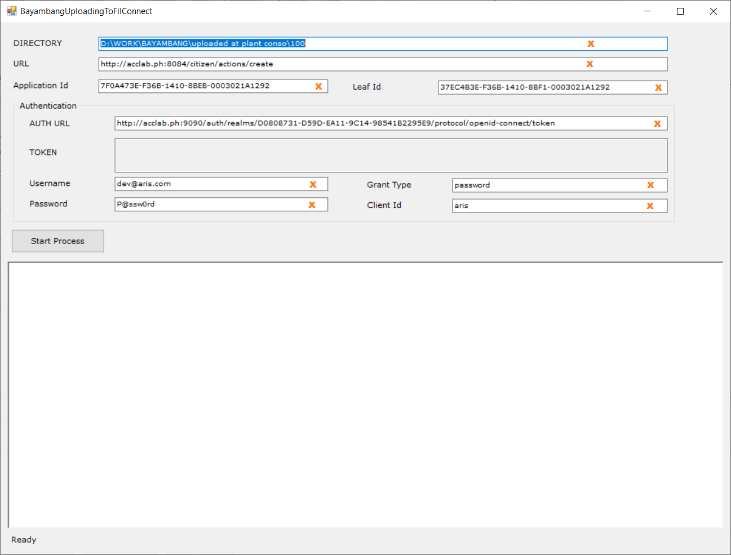

1. Change value of fields with orange X according to SIT/ UAT/ PROD config.
2. Structure of **Source folder (DIRECTORY)**

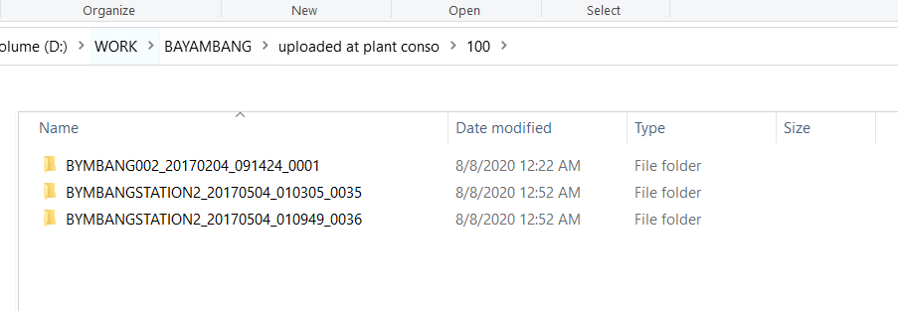

1. Check connection to vpn
2. Initial loading of app is slow if no connection to vpn else
3. Initial loading of app is slow to due to population of excel data to app.